Task 1:

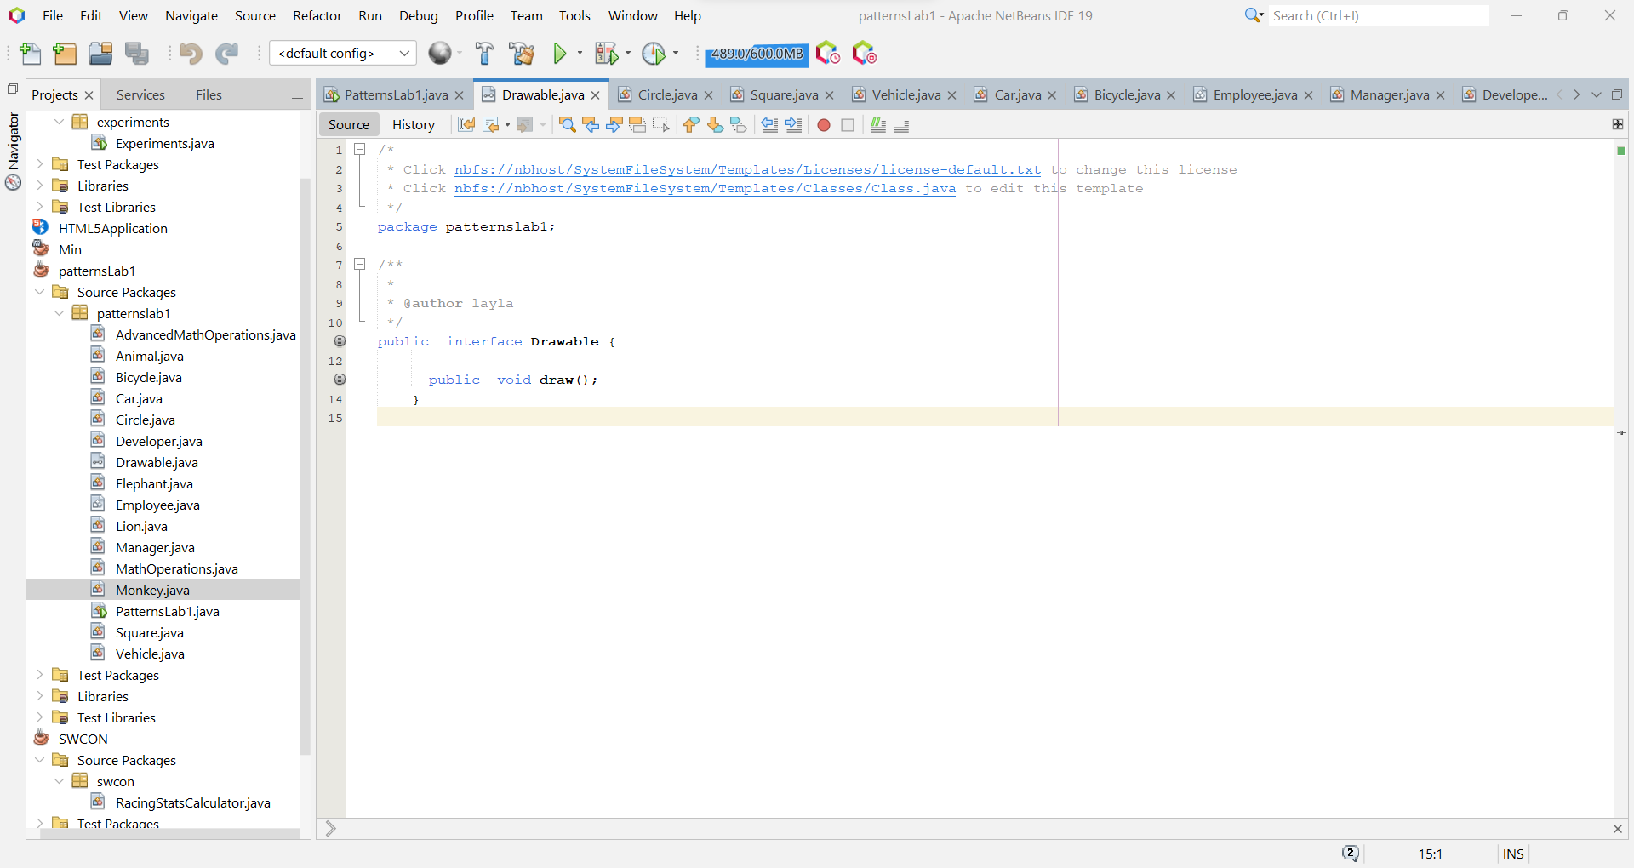

Task 2:

Task 3:

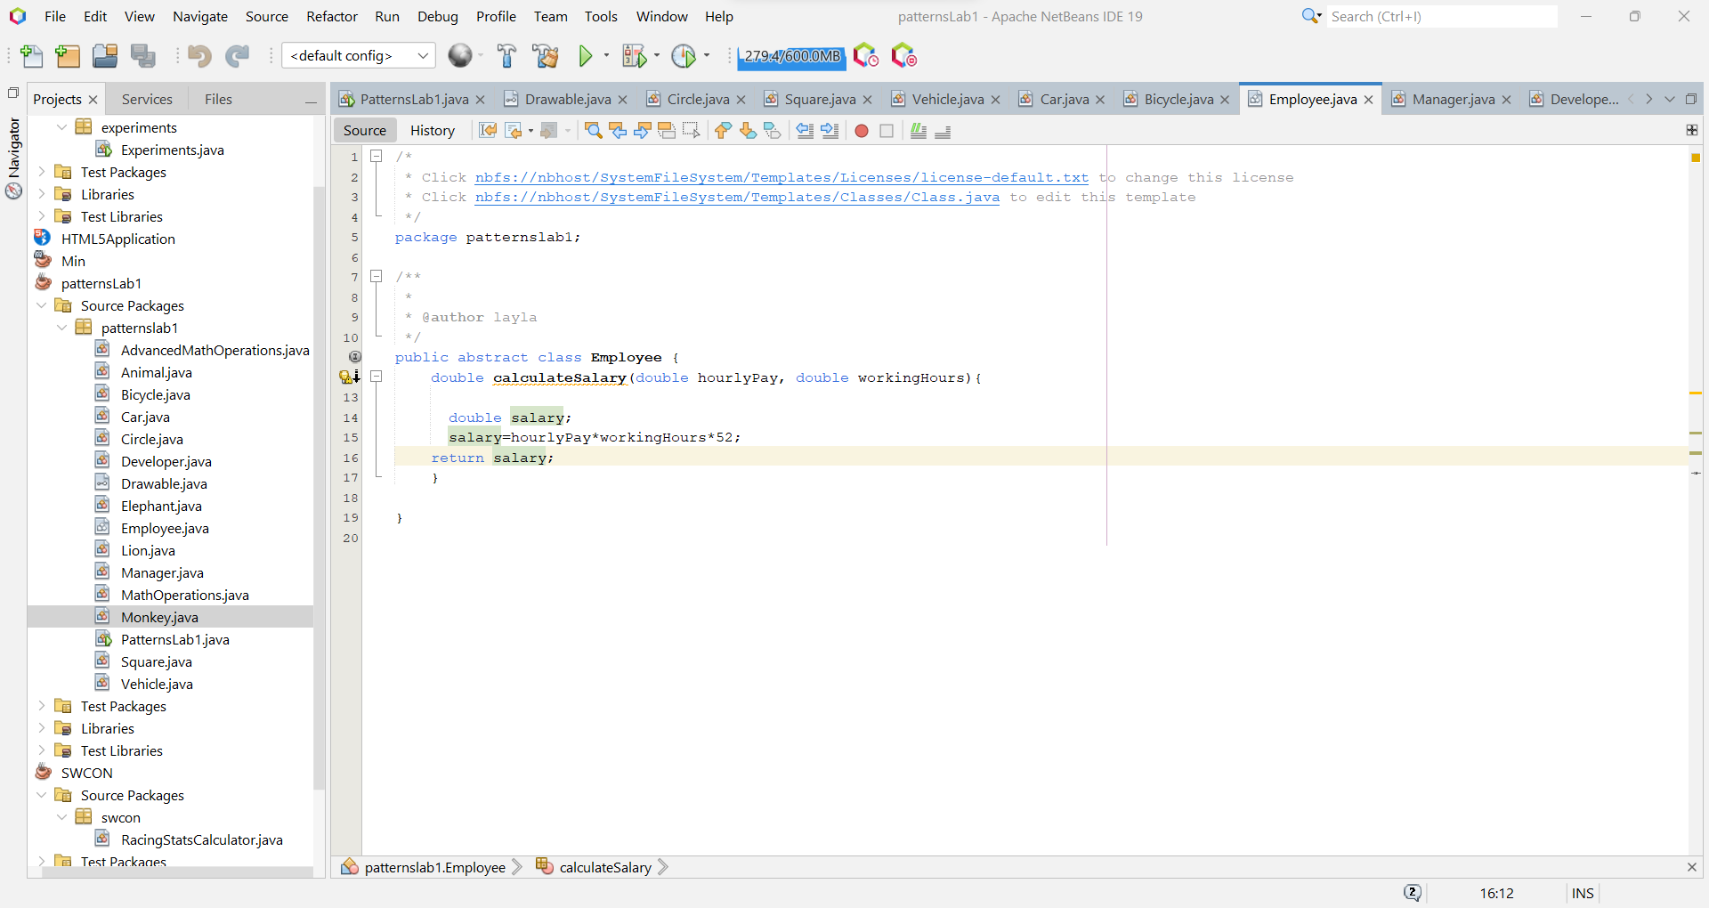

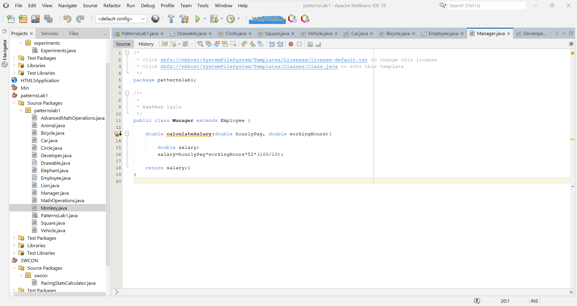

Task 4:

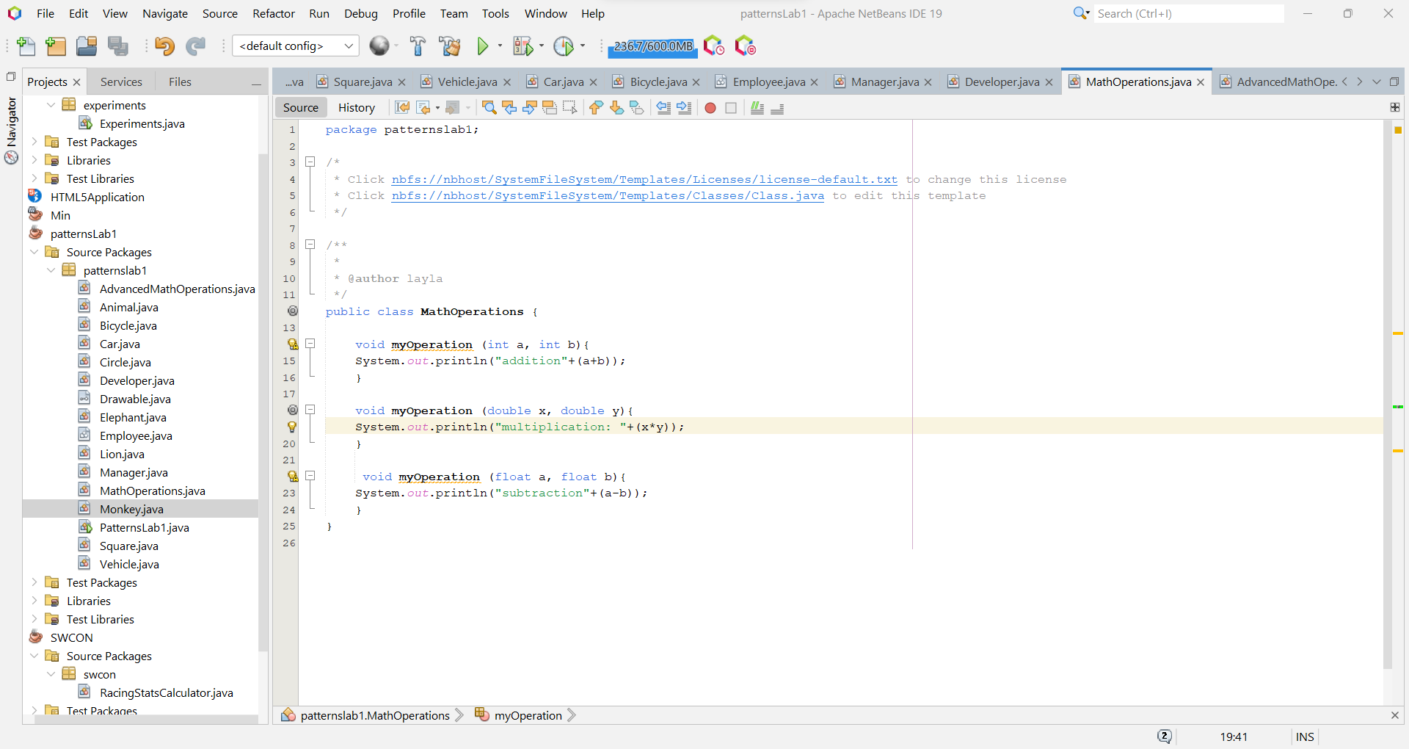

Task 5:

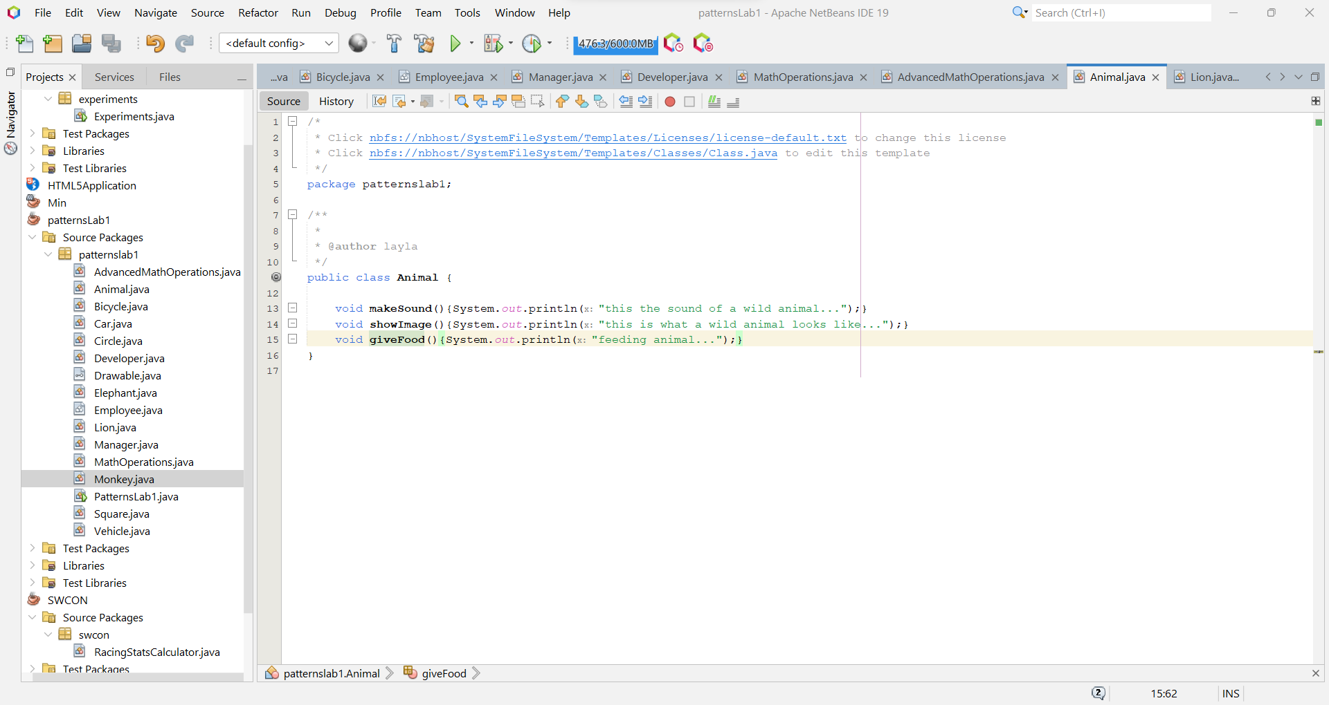

Run for all tasks:

